# DBS301 LAB 5 *– Muhammad Ahmed – 126330166 – Sec* D

Prof. Nebojsa Conkic

Winter 18

1.

select d.department_name, l.city, l.state_province, l.postal_code

from departments d JOIN locations l

USING (location_id)

where d.department_name not like 'S%'

order by l.city, d.department_name;

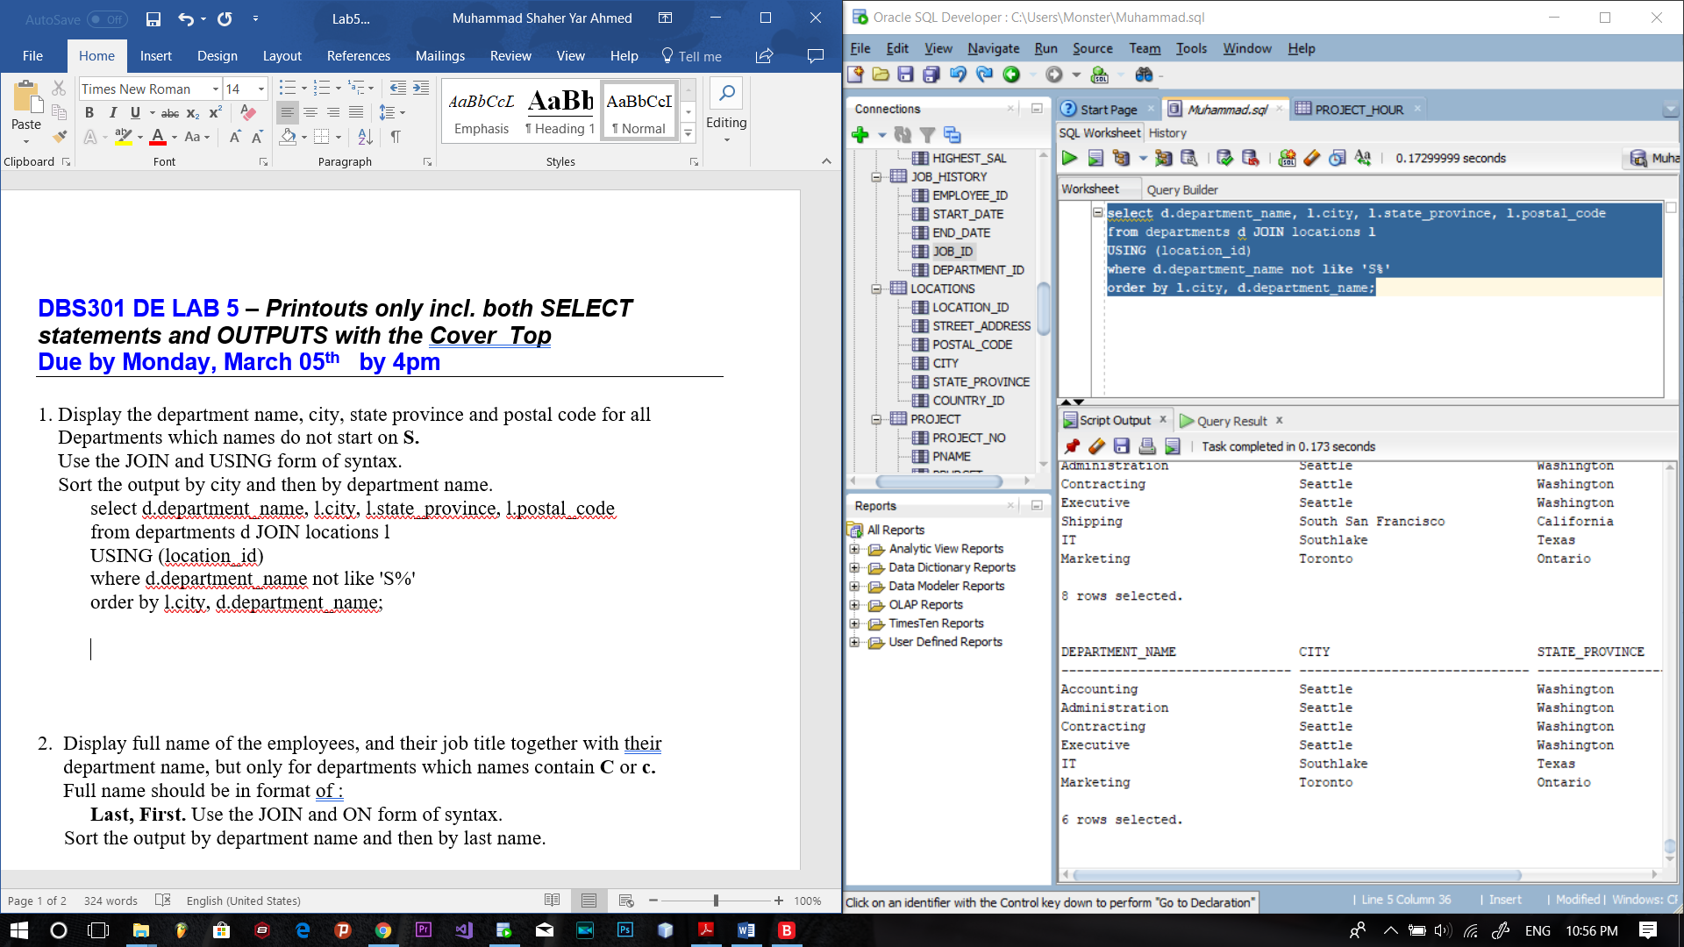

2.

select e.last_name || ', ' || e.first_name "Full Name", e.job_id, d.department_name

from employees e join departments d

on d.department_name like 'C%' or d.department_name like 'c%'

order by d.department_name, e.last_name;

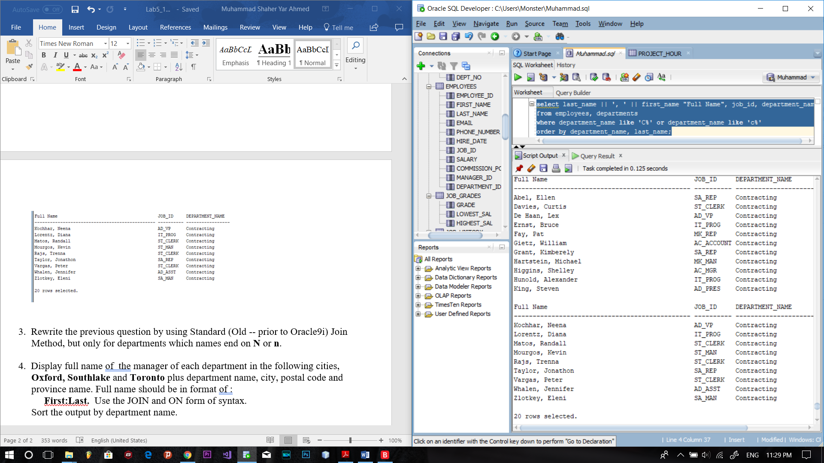

3. select e.last_name || ', ' || e.first_name "Full Name", d.department_name

from employees e, departments d

where department_name like '%N' or department_name like '%n'

order by d.department_name, e.last_name;

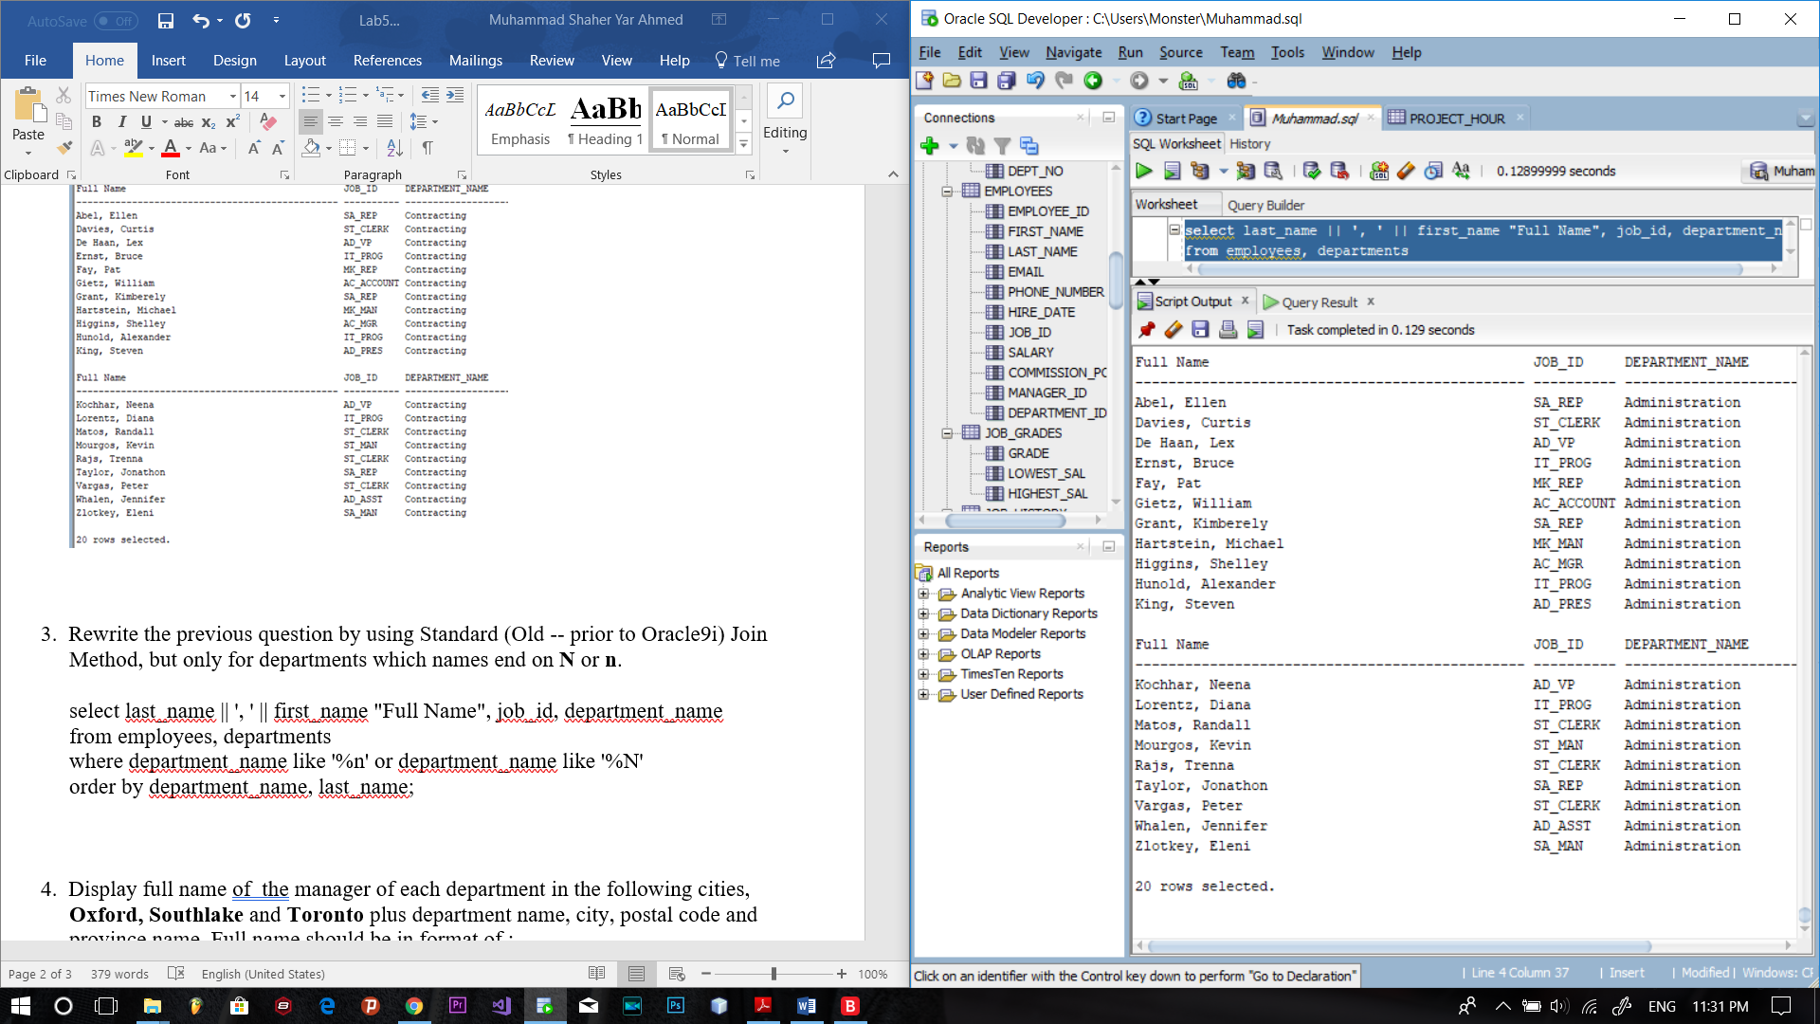

4. select e.last_name || ':' || e.first_name "Manager Name", d.department_name, l.city, l.postal_code, l.state_province

from employees e join departments d on e.department_id = d.department_id

join locations l on d.location_id = l.location_id

and (l.city = 'Oxford' or l.city = 'Southlake' or l.city = 'Toronto')

and (e.manager_id is not null)

order by department_name;

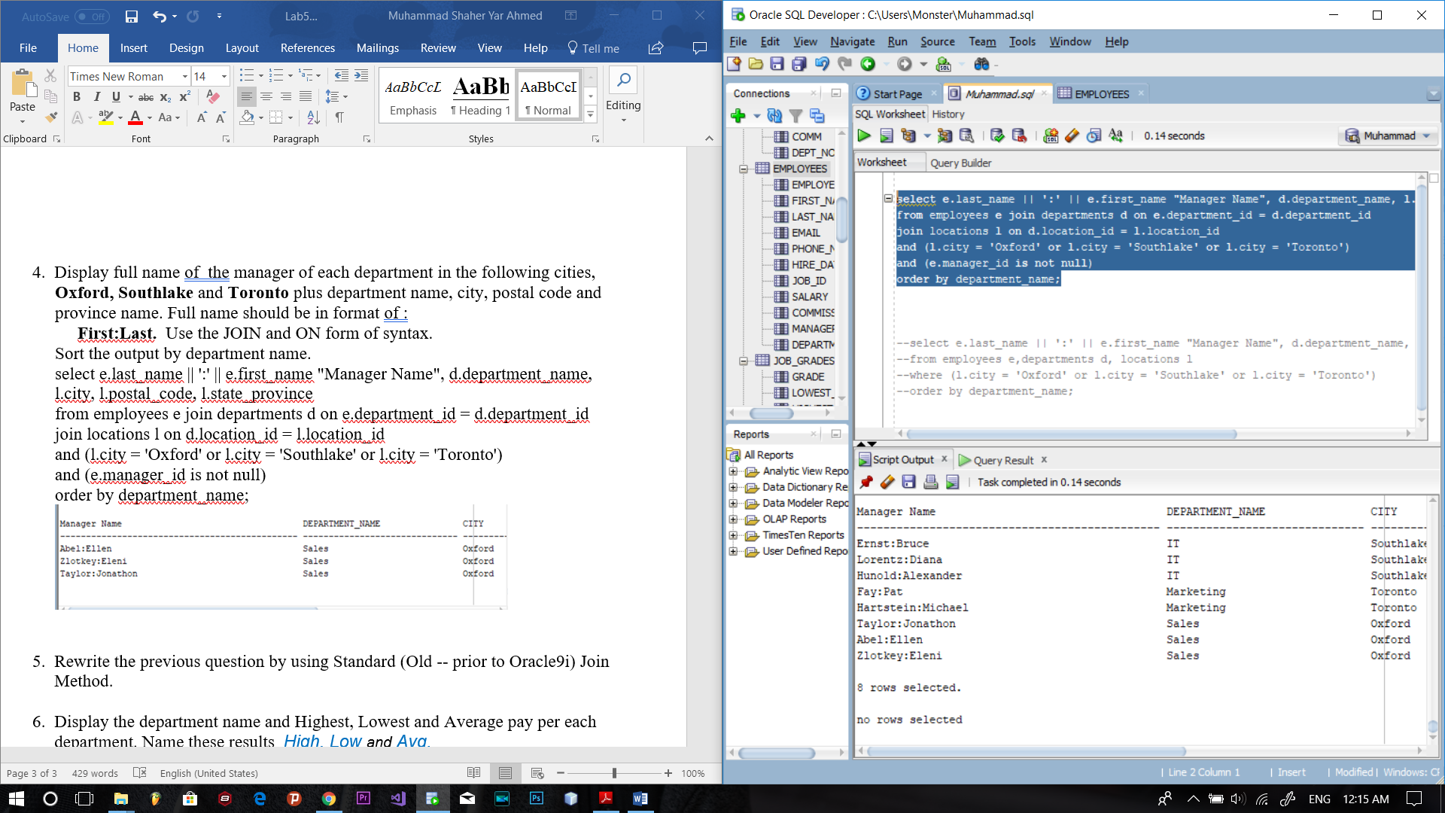

5.

select e.last_name || ':' || e.first_name "Manager Name", d.department_name, l.city, l.postal_code, l.state_province

from employees e,departments d, locations l

where e.department_id = d.department_id

and (d.location_id = l.location_id)

and(l.city = 'Oxford' or l.city = 'Southlake' or l.city = 'Toronto')

and (e.manager_id is not null)

order by department_name;



6.

select max(e.salary) High, min(e.salary) Low, avg(e.salary) Avg, d.DEPARTMENT_NAME

from employees e join departments d

using (DEPARTMENT_ID)

group by (d.DEPARTMENT_NAME)

HAVING max(e.salary) BETWEEN 0 AND 10000

order by max(e.salary) desc;

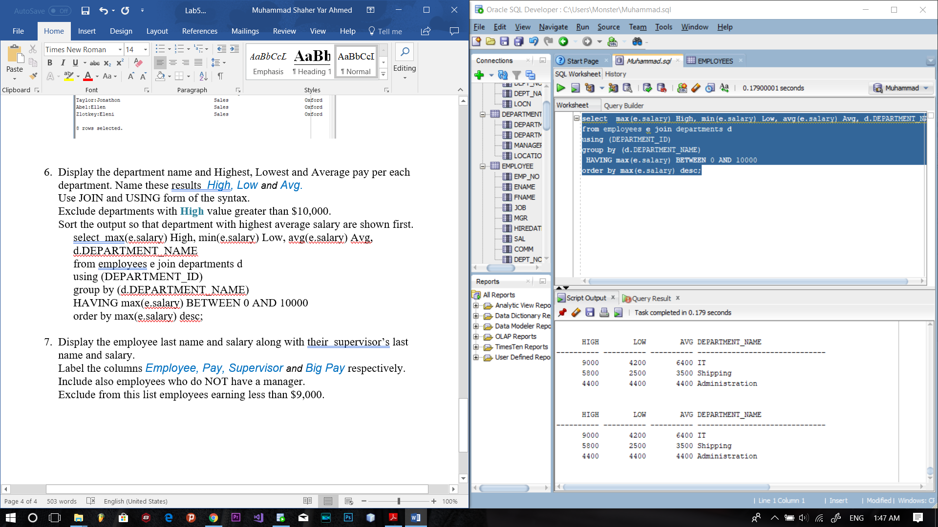

7.

SELECT E.LAST_NAME, E.SALARY PAY, M.LAST_NAME SUPERVISOR, M.SALARY "Big Pay"

FROM EMPLOYEES E

LEFT JOIN EMPLOYEES M

ON (E.MANAGER_ID = M.EMPLOYEE_ID)

WHERE (E.SALARY >= '8999');

